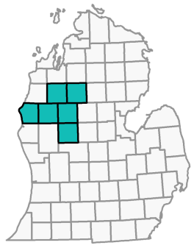
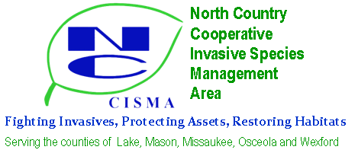
Invasive Treatment Plan and Reward Program Application

Name: Phone:
Mailing Address: _____________________________________________________________________ Email: List species to be controlled: _____________________________________________________________ Dimensions of the area to be treated: Address of location to be treated:
County: Township: Section: GPS Coord.: _______ _
*** Attach map of the location to be treated***
Who will do the treatment? Landowner Contractor Other

Treatment Plan:

- Are any plants to be treated located in standing water? No Yes - If yes, contact NCCISMA for special instructions/permit.
- By signing below I am stating that (check each box):
I agree to pre- and post-treatment inspections by NCCISMA staff, and will not proceed with treatments until I receive notification of application status.
I own the property (Attach copy of property tax statement) I authorize the work being done
I have received and agree to follow basic decontamination procedures to avoid the spreading of invasive species
I will inspect the treated site for the next three years and conduct follow up treatment as needed I grant permission to the NCCISMA to inspect the site pre- and post-treatment

Signature Date

For Staff Use

Pre-Treatment

Application received on __
Application number
Pretreatment inspection on
Meets criteria for reward? No Yes
by

by

Justification:

Post-Treatment
Date work completed
Post-treatment inspection on by
Was treatment carried out according to the plan, and does it appear to be successful? No Yes Justification:

Send completed form to: NCCISMA,437 E. Division St., Cadillac, MI 49601

Reward Program Payment
Date form received: Check made out to:

Check number:
Date of check:_
Amount of check:

Date check mailed:
Treatment site ID number:_________________________________________________
Date of input to MISN: ____________________ Date of input to DEQ: _________________

North Country CISMA mailing address:
437 E Division St.
Cadillac, MI. 49601

